LAKE EAU CLAIRE MANAGEMENT PLAN 2012 GRANT FINAL REPORT

Prepared for the Lake Eau Claire Association by GOES

1/28/2016

GO Environmental Services

Dr. Rod G. Zika, President and Mr. Neil Trombly, GIS Mapping Specialist

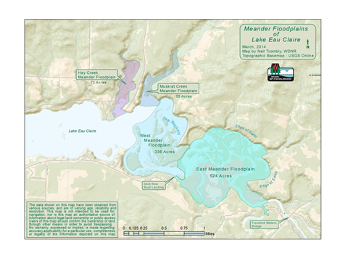

**LAKE EAU CLAIRE MANAGEMENT PLAN 2012 GRANT FINAL REPORT**

The 2012 LEC Management Plan consisted of three main components: (1) Water Quality Proposal, (2) Fisheries and Habitat Proposal, and (3) Sedimentation and Erosion Proposal. All of these components were approved for funding in 2012 and the funded grant activities commenced on October 1, 2012 and after a one year grant extension concluded on January 31, 2015. Although these components are treated separately in the Management Plan they work in unison to indefinitely restore and protect the Lake, to improve water quality and in so doing protect human health. A brief summary of each of the three main components as proposed and then as completed follows. For details on technical issues and arguments, design specifications, and budgets and budget justifications see the main body of the 2012 Management Plan which can be found in the Document Center on the LECA website.

**WATER QUALITY PROPOSAL:**

***AS PROPOSED*:**  A study of phosphorus sources to the lake revealed that roughly 50% comes from internal loading during the summer. A significant reduction of this level of internal load could improve the eutrophic conditions that develop during the summer months. Since most of this internal P arises because anoxic conditions that develop in the western basin of the lake, the efforts concentrated on lowering P levels in the western 200 acres of the lake. Several alternatives to reducing internal P were evaluated and are discussed in the Management Plan. The favored choice because of cost, simplicity and the likelihood of long term success was the installation of a destratification system (Option 3, Section V.A.3c). This system was proposed by the Army Corps of Engineers and involves high pressure compressor driven air injection over a relatively short length of diffuser line located in the deepest portion of the lake. The prediction is that it will destratify most if not all of the deeper portion of the lake where internal P loading is occurring. Modeled estimates from the Army Corps are that this will reduce in-lake TP from105 ug/l to 63 ug/l and that mean chlorophyll a would be reduced from 56 ug/l to 34 ug/l.  This TP loading reduction reduces the frequency of exceeding 50 ug/l chla by 61% from a 45% frequency of occurrence to 18% frequency of occurrence. A further reduction in the TP external loading is expected as part of the Lake Eau Claire restoration plan from the spreading of the present river flow over as much as 200 additional acres (810,000 m2). A significant reduction in flow velocity transport and increased residence time through the restored floodplain above the lake should promote aquatic plant growth and nutrient reduction. So assuming uniform biomass (i.e. macrophytes, epiphytes and plankton) coverage over 200 acres and assuming an average depth of 1 meter the daily SRP reduction in external P source should be significant and add to the benefit of the internal P destratification reduction.

***AS COMPLETED***:  The original plan as submitted to DNR with the permit # IP-WC-2012-18-05603 was modified as indicated in the following 2 amendments. The principles of operation, compressor building location, lake area coverage and other aspects of the total system remained the same. The requested changes are described in the following amendments.

**Amendment 1:**  **Burial of Pipeline at Shoreline**

Compressed air pipeline run from compressor building into lake to a depth where pipeline is deep enough (roughly 4-5 feet) to avoid ice flow damage. At the point of lake entry shown in Figure 1 this will require dredging to a distance of 20-25 feet off the existing shoreline. The 15 compressed air lines coming from the compressor building will be attached to an elevated stairway/boardwalk until they reach the edge of the lake shore where they will be run through buried 8 inch diameter conduit until they reach the lake bottom at a depth of 4-5 feet. Five airlines will be run through each of three conduit pipes. To accomplish this design will require digging a 2 foot wide by 30 foot long trench with a slope of about 20-30 degrees. This will be a wedge shaped trench requiring the removal of no more than 3 cubic yards of material. This could be done manually or with a small backhoe excavator. A temporary retainment barrier may be required and if so will be used on each side of the trench during excavation and placement of the conduit. Once the conduit and airlines are installed in the trench the retainment barrier (if required) will be removed and trench refilled with the originally excavated material. A description of trench and placement is shown in Figure 2. The entire process should be completed in less than a week.

**Amendment 2:**  **Submerged Compressed Airlines, Aerator Type, GPS Coordinates**  Compressed air pipe line supply description and distribution, design characteristics of aerators to be used, and GPS location coordinates of the submerged aerators on the lake bottom are illustrated in Figure 3. This new design has the advantages of being more efficient, easier to install and repair, and easier to fine tune the performance. A lower annual operating cost and a better and larger footprint for the lake destratification area is projected for this new design. These improvements are largely due to better dispersion of the air supply units throughout the complex bathymetric surface of the lake and because of the high level of fine bubble production by each of the 15 aerator units. Figure 3 shows the approximate underwater paths for the airlines. Some of the actual runs were someone displayed from original design specs to avoid underwater features and obstructions and shorten length where possible.

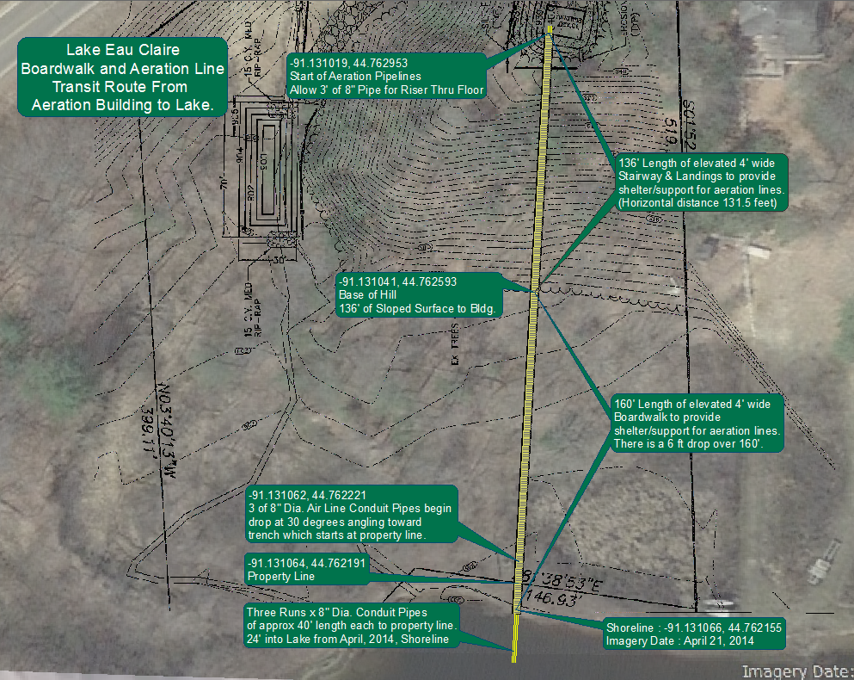

**Figure 1: Boardwalk and Pipeline Path from Compressor Building to Lake**

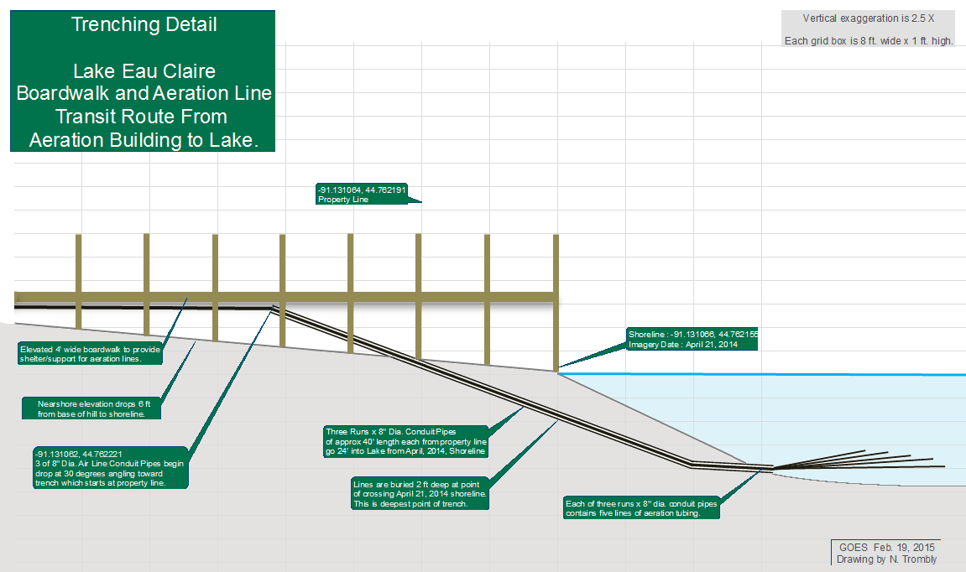

**Figure 2: Transition Description of Pipelines from Boardwalk to Lake Bottom.**

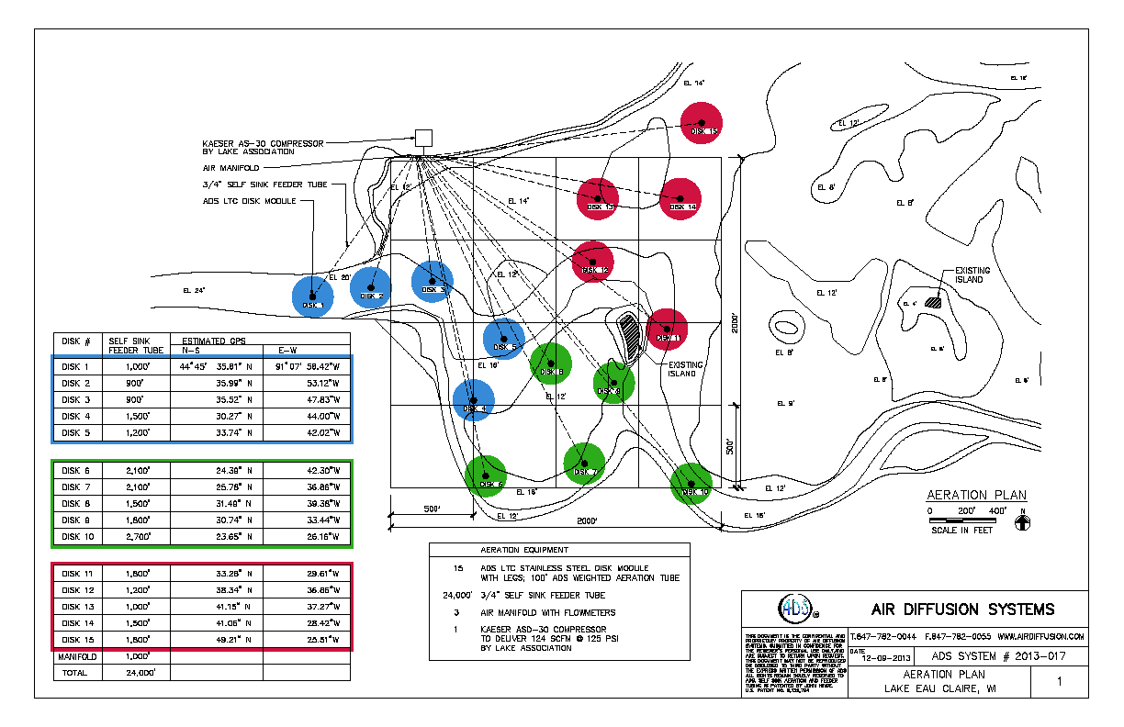

**Figure 3: New 15 Aerator Initial Design Layout**

**FISHERIES AND HABITAT PROPOSAL:**  The proposal calls for adding coarse woody habitat throughout the lake on a controlled basis through the use of blanket permits from DNR and Eau Claire County where required. This process was initiated in 2011 to install both modified half-log structures and tree falls. This is a long term ongoing activity since replacement of habitat will be a continuous issue. The LEC Association sets some annual funds aside for this process, but local and state support will be required particularly during the initial phases of the habitat restoration effort. With the exception of tree falls most of the labor has been voluntary and comes from local invested individuals and organizations like sportsman and fishing clubs. Therefore most of the cost has been for materials and transportation of materials. So far from the first year of operation things have gone according to plan. A pontoon boat was purchased by the LECA to help perform the installations. Roughly 50-100 installations were planned per year until adequate habitat is restored.

What adequate habitat means for LEC is an open question, but as of the 2014-15 management plan the sustainable target number was set at 500 in situ structures. As of the end of 2015 roughly 250 habitat structures have been installed for 62/year since the grant was initiated in 2012 which meets the 50-100 structure/year quota set in the LECAMP. As designed once the total reaches 500 they will be maintained at a steady state average after that point with this annual replacement number is yet to be determined.

**SEDIMENTATION AND EROSION PROPOSAL:**

***As Proposed***: An intensive GIS and on the ground evaluation of sediment sources and deposition was conducted over two years for the north shore of the lake and the Eau River. The primary conclusion was that sedimentation from the tributaries along the north lake shoreline and the river could be shut-off by adding new sediment traps in specific locations. For the north shore of the lake two new sediment traps are proposed on Muskrat Creek and NW Creek. This would make five existing traps along the north shore. The main sediment load to the lake comes from the Eau Claire River and three traps are proposed to handle the sediment load there. If the sedimentation levels remain as they have over the last 73 years this would amount to a 6,900-8,500 yd3/year reduction in sediment advancing towards the lake. In Section C three sediment traps are proposed for installed at TWB, GPT and SRT (see 2014-15 MP Report on the LECA website). Once these traps are installed and maintained as needed the bed load supply of sediment would gradually be reduced between the traps and between TWBT and the lake. This is primarily the result of the river bed scouring as sediment is removed by the traps. As the sediment is removed the flow velocity (at the same river stage height will diminish and sediment transport should decline below the TWB trap as long as no new large erosion sources develop. This will eventually expand navigable areas of the river and also restore original aquatic habitat areas within the flood plain. As an example the main river channel between TWB and GPT would amount to an average annual deepening of the entire width of the river channel of 3.2 to 4.3 inches between these end members. Within three years this could increase the depth of the river by as much as a foot. By time this condition is reached it is important that the main river channel flow rate be reduced by opening flood plain meander channels and sealed oxbows. This should also help to restore some of the valuable fisheries and other wildlife habitat in the headwater area of the lake, since the deepening of the main channel could make these areas accessible again (see LEC Reconnectivity Plan on LECA website).

***As Completed:*** The Eau Claire River traps at TWB and GP were completed as defined in the 2012 Management Plan and accompanying permits. Both traps were completed by mechanical dredging in late summer 2013 and because of excessive flooding in 2014 they were cleaned out again in late January of 2015.

The Skid Row Trap was completed in October 2013 by hydraulic dredging and although it was designed and permitted to have a total capacity of 40,000 yd3 only 20,000 yd3 were slated for 2013. Bathymetric post surveying indicated that in reality only 13-14,000 yd3 of bulked (wet in situ) sediment was removed. As with the TWBT and GPT much of this trap’s capacity was taken up by excessive well above average annual river discharge rates in 2014 and again in 2015.

It was in 2009 that the original stream surveying and sediment trap design was conducted and rapidly escalating per yard costs since then have made it difficult to maintain the original construction and maintenance costs. This coupled with recent way average yearly stream discharge rates have budgeted and progress on the overall sediment management plan difficult.

***Original Project Budgets***

**Water Quality – Aeration System for Destratification**

|  |  |  |  |
| --- | --- | --- | --- |
|  | **Project Costs** | | |
| **Items** | **Requested Funds** | **Cost-Share Value** | **Total Costs** |
| **1. Salaries and benefits1** |  | **$10,000** | **$10,000** |
| **2. Consulting Services2** | **$4000** | **$4,000** | **$8,000** |
| **3. Purchased services3** |  | **$400** | **$400** |
| **4. Other purchased services4** | **$6,000** | **$6,000** | **$12000** |
| **5. Plant material** |  |  |  |
| **6. Supplies5** | **$70,000** | **$10,000** | **$80,000** |
| **7. Depreciation** |  |  |  |
| **8. Hourly equipment charges** |  |  |  |
| **9. State Lab of Hygiene Costs** |  |  |  |
| **10.Non-SLOH Lab costs6** | **$2,000** | **$9,000** | **$11,000** |
| **11.Land or easement acquisition value** |  | **$8,000** | **$8,000** |
| **12.Associated acquisition costs** |  | **$2,000** | **$2,000** |
| **13.Other7** |  | **$850** | **$850** |
| **TOTALS** | **$82,000** | **$50,250** | **$132,250** |

**Fisheries and Habitat**

|  |  |  |  |
| --- | --- | --- | --- |
|  | **Project Costs** | | |
| **Items** | **Requested Funds** | **Cost-Share Value** | **Total Costs** |
| **1. Salaries and benefits1** |  | **$6,000** | **$6,000** |
| **2. Consulting Services** |  |  |  |
| **3. Purchased services3** |  | **$200** | **$200** |
| **4. Other purchased services** |  |  |  |
| **5. Plant material8** | **$2,500** | **$3,000** | **$5,500** |
| **6. Supplies9** | **$3,000** | **$2,000** | **$5,000** |
| **7. Depreciation** |  |  |  |
| **8. Hourly equipment charges10** | **$2,475** |  | **$2,475** |
| **9. State Lab of Hygiene Costs** |  |  |  |
| **10.Non-SLOH Lab costs** |  |  |  |
| **11.Land or easement acquisition value** |  |  |  |
| **12.Associated acquisition costs** |  |  |  |
| **13.Other7** |  | **$850** | **$850** |
| **SUBTOTALS** | **$7,975** | **$12,050** | **$20,025** |

**Sedimentation and Erosion**

|  |  |  |  |
| --- | --- | --- | --- |
|  | **Project Costs** | | |
| **Items** | **Requested Funds** | **Cost-Share Value** | **Total Costs** |
| **1. Salaries and benefits1** |  | **$4,000** | **$4,000** |
| **2. Consulting Services** |  |  |  |
| **3. Purchased services3** |  | **$400** | **$400** |
| **4. Other purchased services11** | **$110,000** | **$113,000** | **$223,000** |
| **5. Plant material** |  |  |  |
| **6. Supplies** |  |  |  |
| **7. Depreciation** |  |  |  |
| **8. Hourly equipment charges** |  |  |  |
| **9. State Lab of Hygiene Costs** |  |  |  |
| **10.Non-SLOH Lab costs** |  |  |  |
| **11.Land or easement acquisition value** |  |  |  |
| **12.Associated acquisition costs** |  |  |  |
| **13.Other** |  |  |  |
| **TOTALS** | **$110,000** | **$117,400** | **$227,400** |

**GRAND TOTAL FOR A, B, and C $199,975 $179,700 $379,675**

**Budget Justification for Footnotes in Budgets A, B, and C Above**1. Salary and Benefits: This is cost sharing for Dr. Zika’s time in overseeing this project. As a professional consultant for industry and government agencies such as the EPA he normally receives daily consulting fees of $500-$1000 plus expenses. Therefore at $500/day for the duration of this project he is committed to 40 days. He is currently a professor at the University of Miami and this amount of time consulting is legally provided under contract terms of employment with the University. This consulting time will be subdivided between the separate projects.

2. Consulting services: This is for having an engineering consultant familiar with installation of lake aeration systems provide oversite in the design and construction of aeration system for the lake. The LEC Association has already employed Mr. James Wedepohl (formally with DNR) as a consultant in the design of the lake aeration system. He has agreed to continue in a consultant capacity during the construction and startup phases.

3. Purchased services: Mainly for office related costs, communications, and shipping costs.

4. Other purchased services: These are costs for equipment and personnel for installation of aeration pipe line and for diver expenses. Two weeks have been scheduled for the installation time.

5. Supplies: This includes all the material costs for the aeration system (i.e compressor, 3-phase power converter and other electrical hardware, valves, piping, iron ballast, strapping, etc.)

6. Non-SLOH Lab costs: To determine the operating parameters and establish the effectiveness of the aeration system pre-installation and post-installtion monitoring will be conducted. This will be done as it has been in the past with members from the Beaver Creek Reserve and Wildland School in Eau Claire County. Dr. Zika will supply some of necessary equipment and supplies from his lab at the University of Miami. Among the measured parameters oxygen, phopshate, light penetration, and phytoplankton speciation will be evaluated.

7. Other: These funds will be used to cover insurance costs for liability exposure to the Lake Association. Of the activites the Association is promoting through the management plan, the liability risks associated with them increase.

8. Plant material: As discussed in the objectives section, tree falls will be widely used around the lake to increase CWH. Where existing shoreline trees are used for CWH, they will be replaced with newly planted shoreline trees. In addition in certain location selected shoreline or aquatic plants such as bull rushes will be established as shoreline habitat and for shoreline erosion protection.

9. Supplies: These funds are to be used for installation of tree falls and half log structures for fish habitat. Included in the list of supplies are strapping , concrete block, etc.

10. Hourly equipment charges: Some funds will be required for moving and installing trees for tree falls. Some of these trees will be moved and installed during the winter months to take advantage of ice cover.

11. Other purchased services: Paying for sediment removal in the two traps in the river above the lake. The lowest price we have been quoted by one company is $4.00/yd3. A price of $4 to $5 was used to determine the size and cost of the upstream sediment traps at SRT and GPT sites (see Table 9).

***Original Project Timelines***

This project is designed to be started in the late Summer of 2012 andcompleted over a two year period. Assumming that the project begins on schedule the major tasks are projected for completion by September 30, 2014. See Appendix C for timeline details.

**Project Timelines**

|  |  |  |  |  |  |
| --- | --- | --- | --- | --- | --- |
| NUMBER | TASK | RESOURCE | START | END | DURATION |
| 1 | Boat Landing Invasive Species Creel Reporting Surveys and Education | Beaver Creek & LEC Volunteers | 10/01/2012 | 11/01/2014 | 525 |
| 2 | Aeration Detail Design | Engineering Consultants | 11/01/2012 | 02/02/2013 | 63 |
| 3 | Aeration Construction Phase – Pipe Line Installation | TBD & Volunteers | 07/01/2013 | 07/01/2014 | 165 |
| 4 | Aeration Pump House Construction | TBD & Volunteers | 07/01/2013 | 10/31/2013 | 85 |
| 5 | Aeration System Startup & Testing Phase | LEC Assoc. & Beaver Creek Reserve & Wildland School | 05/01/2014 | 11/01/2014 | 128 |
| 6 | Install Tree Falls and Half-Log Structures – Ungoing Program | LEC Assoc., DNR, Local Volunteers | 10/01/2012 | 12/31/2014 | 564 |
| 7 | Sediment Removal Engineering Completion Design Phase & Contract Development | TBD & LEC Assoc. | 10/01/2012 | 04/01/2013 | 124 |
| 8 | Sediment Removal Projects | TBD, DNR, LEC Assoc. | 05/15/2013 | 11/01/2014 | 369 |
| 9 | River Flood Plain Restoration Flow Study & Deposition Rate Surveys | DNR & LEC Assoc. | 10/01/2012 | 12/31/2014 | 564 |
| 10 | Submit Project Final Report | LEC Assoc. | - | 01/31/2015 | - |

***Project Deadlines and Expenditures***: The only major delay in schedule was for the aeration system completion and startup operation which was completed in summer of 2015. This was about one year behind schedule. The delay was largely the result of aerator compressor building and pipeline land acquisition problems and a re-engineering and construction design of the complete system (see section on water quality above for more details).

Total expenditures for the grant period $618,747.37 of which $418,772.37 was cost sharing from the LECA, LECD, Eau Claire County, and local townships. This is far in excess of the total committed grant cost sharing of $179,400. Also what is not included in the cost sharing is the generous volunteer support from the LEC community of $45,684 ($12/hour) and an estimated volunteer professional support of roughly $85,000 ($500/day).

***Actual Lake Management Grant Expenses***



